**Ask Me Coffee | AK**

A Skill Oriented Course Web Application / Project report

Submitted in the partial fulfillment of the requirements for

the award of the degree of

Bachelor of Technology

in

Computer Science and Engineering

by

JAMMULA ANAND KUMAR

21761A0523

Under the guidance of

P. Jagadeeswara Rao

Assistant Professor, Dept. of CSE



**Department of Computer Science and Engineering**

**Lakireddy Bali Reddy College of Engineering (Autonomous)**

**Accredited by NAAC & NBA (Under Tier - I)**

**Affiliated to JNTUK, Kakinada; ISO 9001:2015 Certified**

**2021-22**



**Certificate**

This is to certify that the Skill Oriented Course Web Application / Project entitled “**Ask Me Coffee | AK**” is being submitted by **Jammula Anand Kumar** in partial fulfillment for the award of B. Tech in Computer Science & Engineering to the Jawaharlal Nehru Technological University Kakinada is a record of bonafide work carried out by him/her under our guidance.

The results embodied in this Skill Oriented Course Web Application / Project report have not been submitted to any other University or Institute for the award of any degree or diploma.

**Project guide Head of the department**

Mr. P. Jagadeeswara Rao Dr. D. Veeraiah

Assistant Professor Professor

**External Examiner**

**ACKNOWLEDGEMENT**

I would like to thank **Mr. P. Jagadeeswara Rao** Assistant Professor**,** CSE department for the encouragement and support in carrying out this Skill Oriented Course Web Application / Project.

I also take the privilege to record my thanks to **Dr. D. Veeraiah,** Professor,and Head of the Department of CSE whose encouragement, cooperation, and valuable support crown my success.

I express my for thanks to the support given by management in completing my Web Application / Project. I also express my sincere gratitude & deep sense of respect to the Principal, **Dr.K. Appa Rao** for making us available all the required assistance for and his support and inspiration to carry out this Skill Oriented Course Web Application / Project in the Institute.

I am thankful to the teaching and non-teaching staff of CSE department for their direct as well as indirect help in my Skill Oriented Course Web Application / Project.

I am elated to avail my selves to this opportunity to express my deep sense of gratitude to my parents.

**Skill Oriented Course Web Application / Project Title**

**Abstract**

Almost 80% of the population are coffee lovers. Kaffinite sunshine cafe is guaranteed to become a daily necessity for all coffee addicts. A place with a good ambiance where people can escape from their daily stress and cherish a morning cup of coffee. Our cafe offers home-style delicious breakfast and snacks. We focus on finding the most aromatic and exotic coffee beans. We have branches in many cities of Tamil Nadu.

We have a romantic ambiance that attracts youth. Our cafe has spectacular interior designs with a stupendous taste of coffee. We have attached our menu which contains multi-cuisines at attractive prices. In this paper, we have done a SWOT analysis of our cafe to know our strengths and weaknesses. We have also analyzed our opportunities and threats from the external environment.

**CONTENTS**

**CONCEPTS Page No**

01

02-05

06

07

08

09-45

46-56

57-58

59

60

1. Introduction

2. Tags and Functions

2.1 HTML Tags

2.2 Java Script Functions

2.3 CSS Styles

3. References

3.1 Collecting Pictures and Paragraphs

4. Implementation

4.1 Creating HTML Pages

4.2 Applying CSS Styling

4.3 Applying JS Functions

5. Result Web page

6. Conclusion

**LIST OF IMAGES**

**CONCEPTS**

4.1  **Page No**

1. Home Page 61
2. Products Page 62
3. Product-details 63
4. About page 64
5. Contact page 65
6. Account page 66
7. My cart page 67

1. **INTRODUCTION**

Drinking Coffee on a daily basis is a way of life here in Ashland Oregon. This is precisely why I plan on opening a coffee shop in this small and quaint town where the people love each other as much as they love their coffee. I intend to sell freshly brewed coffee using these techniques; cold drip, French press, pour-over, and syphon.

The earliest credible evidence of coffee-drinking or knowledge of the coffee tree appears in the middle of the 15th century in the accounts of Ahmed al-Ghaffar in Yemen. It was here in Arabia that coffee seeds were first roasted and brewed in a similar way to how it is prepared now.

The products I will be offering include coffee, coffee beans, coffee cups, gift cards, baked goods, and coffee making equipment such as filters and French presses, etc. The Sleepy Armadillo Coffee House will provide coffee, food, entertainment, and a welcoming environment for the local community.

This web project contains the complete information about a Coffee Shop provided in the Internet. The web project Contains totally 7 webpages, which provides the total information. Firstly contains the Home webpage, contains the short note and available items in the shop.

It provides all information and required information about a Coffee shop. Which contains a login page, a registretion page, all product avilable page and add to cart page to order the items.

1. **TAGS AND FUNCTIONS**

**2.1 HTML TAGS**

**HTML INTRODUCTION:**

HTML is an acronym which stands for Hyper Text Markup Language which is used for creating web pages and web applications. Let's see what is meant by Hypertext Markup Language, and Web page.

Hyper Text: HyperText simply means "Text within Text." A text has a link within it, is a hypertext. Whenever you click on a link which brings you to a new webpage, you have clicked on a hypertext. HyperText is a way to link two or more web pages (HTML documents) with each other.

Markup language: A markup language is a computer language that is used to apply layout and formatting conventions to a text document. Markup language makes text more interactive and dynamic. It can turn text into images, tables, links, etc.

Web Page: A web page is a document which is commonly written in HTML and translated by a web browser. A web page can be identified by entering an URL. A Web page can be of the static or dynamic type. With the help of HTML only, we can create static web pages.

Hence, HTML is a markup language which is used for creating attractive web pages with the help of styling, and which looks in a nice format on a web browser. An HTML document is made of many HTML tags and each HTML tag contains different content.

In the late 1980's , a physicist, Tim Berners-Lee who was a contractor at CERN, proposed a system for CERN researchers. In 1989, he wrote a memo proposing an internet based hypertext system.

Tim Berners-Lee is known as the father of HTML. The first available description of HTML was a document called "HTML Tags" proposed by Tim in late 1991. The latest version of HTML is HTML5, which we will learn later in this tutorial.

**TAGS DESCRIPTION**

<!--...--> Defines a comment

<!DOCTYPE> Defines the document type

<a> Defines a hyperlink. Defines an embedded applet

<article> Defines an article

<audio> Defines embedded sound content

<b> Defines bold text

<base> Specifies the base URL/target for all relative URLs in a document

<basefont> Not supported in HTML5. Use CSS instead. Specifies a default color, size, and font for all text in a document

<big> Not supported in HTML5. Use CSS instead. Defines big text

<body> Defines the document's body

<br> Define a single-line break

<button> Defines a clickable button

<caption> Defines a table caption

<center> Not supported in HTML5. Use CSS instead. Defines centered text

<col> Specifies column properties for each column within a <colgroup> element

<colgroup> Specifies a group of one or more columns in a table for formatting

<dd> Defines a description/value of a term in a description list

<div> Defines a section in a document

<em> Defines emphasized text

<embed> Defines a container for an external application

<fieldset> Groups related elements in a form

<font> Not supported in HTML5. Use CSS instead. Defines font, color, and size for text

<footer> Defines a footer for a document or section

<form> Defines an HTML form for user input

<frame> Not supported in HTML5. Defines a window (a frame) in a frame set

<frameset> Not supported in HTML5. Defines a set of frames

<h1> to <h6> Defines HTML headings

<head> Contains metadata/information for the document

<header> Defines a header for a document or section

<hr> Defines a thematic change in the content

<html> Defines the root of an HTML document

<i> Defines a part of text in an alternate voice or mood

<iframe> Defines an inline frame

<img> Defines an image

<input> Defines an input control

<label> Defines a label for an <input> element

<legend> Defines a caption for a <fieldset> element

<li> Defines a list item

<link> Defines the relationship between a document and an external resource (most used to link to style sheets)

<main> Specifies the main content of a document

<meta> Defines metadata about an HTML document

<nav> Defines navigation links

<ol> Defines an ordered list

<option> Defines an option in a drop-down list

<p> Defines a paragraph

<script> Defines a client-side script

<section> Defines a section in a document

<select> Defines a drop-down list

<small> Defines smaller text

<span> Defines a section in a document

<strong> Defines important text

<style> Defines style information for a document

<table> Defines a table

<tbody> Groups the body content in a table

<td> Defines a cell in a table

<th> Defines a header cell in a table

**2.2 JAVA SCRIPT INTRODUCTION**

JavaScript (js) is a light-weight object-oriented programming language which is used by several websites for scripting the web pages. It is an interpreted, full-fledged programming language that enables dynamic interactivity on websites when applied to an HTML document. It was introduced in the year 1995 for adding programs to the web pages in the Netscape Navigator browser. Since then, it has been adopted by all other graphical web browsers. With JavaScript, users can build modern web applications to interact directly without reloading the page every time. The traditional website uses js to provide several forms of interactivity and simplicity.

Although, JavaScript has no connectivity with the Java programming language. The name was suggested and provided in the times when Java was gaining popularity in the market. In addition to web browsers, databases such as CouchDB and MongoDB use JavaScript as their scripting and query language.

In 1993, Mosaic, the first popular web browser, came into existence. In the year 1994, Netscape was founded by Marc Andreessen. He realized that the web needed to become more dynamic. Thus, a 'glue language' was believed to be provided to HTML to make web designing easy for designers and part-time programmers. Consequently, in 1995, the company recruited Brendan Eich, intending to implement and embed Scheme programming language to the browser. But, before Brendan could start, the company merged with Sun Microsystems for add Java into its Navigator so that it could compete with Microsoft over the web technologies and platforms.

Now, two languages were there: Java and the scripting language. Furthermore, Netscape decided to give a similar name to the scripting language as Java's. It led to 'Javascript'. Finally, in May 1995, Marc Andreessen coined the first code of Javascript named 'Mocha'. Later, the marketing team replaced the name with 'LiveScript'. But, due to trademark reasons and certain other reasons, in December 1995, the language was finally renamed to 'JavaScript'. From then, JavaScript came into existence**.**

**2.3 CSS STYLING**

CSS stands for Cascading Style Sheets. It is a style sheet language which is used to describe the look and formatting of a document written in markup language. It provides an additional feature to HTML. It is generally used with HTML to change the style of web pages and user interfaces. It can also be used with any kind of XML documents including plain XML, SVG and XUL.

CSS is used along with HTML and JavaScript in most websites to create user interfaces for web applications and user interfaces for many mobile applications.

1) Solves a big problem

Before CSS, tags like font, color, background style, element alignments, border and size had to be repeated on every web page. This was a very long process. For example: If you are developing a large website where fonts and color information are added on every single page, it will be become a long and expensive process. CSS was created to solve this problem. It was a W3C recommendation.

2) Saves a lot of time

CSS style definitions are saved in external CSS files so it is possible to change the entire website by changing just one file.

3) Provide more attributes

CSS provides more detailed attributes than plain HTML to define the look and feel of the websit

1. **REFERENCES**

**Images Source:**

**Source 1:** <https://unsplash.com/s/photos/coffee-cup/>

**Source 2:** <https://www.pexels.com/search/coffee/>

**Source 3:** [https://pixabay.com/images/search/coffee](https://pixabay.com/images/search/coffee/)**[/](https://pixabay.com/images/search/coffee/)**

**Source 4:** <https://www.coca-colaindia.com/homepage>

**Source 5:**  <https://www.starbucks.com/>

**Paragraph Source:**

**Source 1:** <https://edgearticles.com/2018/10/04/short-paragraph-on-coffee/>

**Source 2:** <https://www.thepioneerwoman.com/food-cooking/a35153729/types-of-coffee/>

**Source 3:** <https://pricee.com/coffee/coffee-products-price-in-india>

**Source 4:** <https://pricee.com/coffee/coffee-products-price-in-india>

1. **IMPLEMENTATION**
   1. **Creating HTML Pages**

**Main.html:**

**<!DOCTYPEMhtml>**

**<html lang="en">**

**<head>**

**<meta charset="UTF-8">**

**<title>Ask Me Coffee | AK</title>**

**<link rel="stylesheet" href="style.css">**

**<link rel="preconnect" href="https://fonts.googleapis.com">**

**<link href="https://fonts.googleapis.com/css2?family=Poppins:wght@300;400;500;600;700&display=swap" rel="stylesheet">**

**<link rel="stylesheet" href="https://stackpath.bootstrapcdn.com/font-awesome/4.7.0/css/font-awesome.min.css">**

**</head>**

**<body>**

**<div class="bgcolor">**

**<div class="header">**

**<div class="container">**

**<div class="navbar">**

**<div class="logo">**

**<img src="images/logo.jfif" width="125px">**

**</div>**

**<nav>**

**<ul>**

**<li><a href="main.html" class="active">Home</a></li>**

**<li><a href="products.html">Products</a></li>**

**<li><a href="product-details.html">Product-details</a></li>**

**<li><a href="about.html">About</a></li>**

**<li><a href="contact.html">Contact</a></li>**

**<li><a href="account.html">Account</a></li>**

**<li><a href="cart.html"><img src="images/cart.png" width="30px" height="30px"><br>My Cart</a></li>**

**</ul>**

**</nav>**

**</div>**

**<div class="row">**

**<div class="col-2">**

**<h1><i>Ask Me Coffee -AK</i></h1><br><br>**

**<h1>COFFEE<br>A Hot Cup of Happiness!</h1>**

**<p>Coffee is a beverage brewed from the roasted and ground seeds of the tropical evergreen coffee plant.<br> Coffee is one of the three most popular beverages in the world.</p>**

**<a href="products.html" class="btn">Explore Now &#8594;</a>**

**</div>**

**<div class="col-2">**

**<img src="images/image1.avif" >**

**</div>**

**</div>**

**</div>**

**</div>**

**<!-------- featured categories--------->**

**<div class="categories">**

**<div class="small-container">**

**<h2 class="title">Special Products</h2>**

**<div class="row">**

**<div class="col-3">**

**<img src="images/catg-1.jpg">**

**</div>**

**<div class="col-3">**

**<img src="images/catg-2.jpg">**

**</div>**

**<div class="col-3">**

**<img src="images/catg-3.jpg">**

**</div>**

**</div>**

**</div>**

**</div>**

**<!-------- featured products--------->**

**<div class="small-container">**

**<!------------- Latest products------------->**

**<a href="products.html"><h2 class="title">Latest Products</h2></a>**

**<div class="row">**

**<div class="col-4">**

**<img src="images/product-5.jpg">**

**<h4>Americano Coffee</h4>**

**<div class="rating">**

**<i class="fa fa-star" ></i>**

**<i class="fa fa-star" ></i>**

**<i class="fa fa-star" ></i>**

**<i class="fa fa-star-half-o" ></i>**

**<i class="fa fa-star-o"></i>**

**</div>**

**<p>$2.50</p>**

**</div>**

**<div class="col-4">**

**<img src="images/product-6.jpg">**

**<h4>Café au Lait Coffee</h4>**

**<div class="rating">**

**<i class="fa fa-star" ></i>**

**<i class="fa fa-star" ></i>**

**<i class="fa fa-star" ></i>**

**<i class="fa fa-star-o" ></i>**

**<i class="fa fa-star-o" ></i>**

**</div>**

**<p>$0.70</p>**

**</div>**

**<div class="col-4">**

**<img src="images/product-7.jpg">**

**<h4>Red Eye Coffee</h4>**

**<div class="rating">**

**<i class="fa fa-star" ></i>**

**<i class="fa fa-star" ></i>**

**<i class="fa fa-star" ></i>**

**<i class="fa fa-star" ></i>**

**<i class="fa fa-star"></i>**

**</div>**

**<p>$1.75</p>**

**</div>**

**<div class="col-4">**

**<img src="images/product-8.jpg">**

**<h4>Cortado Coffee</h4>**

**<div class="rating">**

**<i class="fa fa-star" ></i>**

**<i class="fa fa-star" ></i>**

**<i class="fa fa-star" ></i>**

**<i class="fa fa-star" ></i>**

**<i class="fa fa-star-half-o"></i>**

**</div>**

**<p>$0.90</p>**

**</div>**

**</div>**

**</div>**

**<!------------- offered products------------->**

**<div class="Offer">**

**<div class="small-container">**

**<div class="row">**

**<div class="col-2">**

**<img src="images/offer.jpg" class="Offer-img">**

**</div>**

**<div class="col-2">**

**<p>Exclusively Available on "Ask Me Coffee | AK"</p>**

**<h1>Special<br>Chinese tea</h1>**

**<small>Tea is a beverage made from the leaves of tea plants (Camellia sinensis) and boiled water. Tea leaves are processed using traditional Chinese methods. Chinese tea is consumed throughout the day, including during meals, as a substitute for plain water, well-being or for simple pleasure.</small>**

**<a href="cart.html" class="btn">Order Now&#8594;</a>**

**</div>**

**</div>**

**</div>**

**</div>**

**<!------------testmonial---->**

**<div class="testmonial">**

**<div class="small-container">**

**<div class="row">**

**<div class="row">**

**<p><center>It was kindly sent with other puerh samples from Daniel of Vancouver's famed The Chinese Tea Shop.<br></center></p>**

**<div class="rating">**

**<i class="fa fa-star" ></i>**

**<i class="fa fa-star" ></i>**

**<i class="fa fa-star" ></i>**

**<i class="fa fa-star" ></i>**

**<i class="fa fa-star-o"></i>**

**</div>**

**</div>**

**</div>**

**</div>**

**</div>**

**<!---------brands---------->**

**<div class="brand">**

**<h2 class="title">Other Brands</h2>**

**<div class="small-container">**

**<div class="row">**

**<div class="col-5">**

**<center><a href="https://online.kfc.co.in/"><img src="images/logo-1.jpg">**

**<h4>* KFC*</h4></a></center>**

**</div>**

**<div class="col-5">**

**<center><a href="https://www.starbucks.in/dashboard"><img src="images/logo-2.jpg">**

**<h4><b>*StarBucks *</b></h4></a></center>**

**</div>**

**<div class="col-5">**

**<center><a href="https://www.mcdonalds.com/us/en-us.html"><img src="images/logo-3.jpg">**

**<h4>* McDonald's *</h4></a></center>**

**</div>**

**<div class="col-5">**

**<center><a href="https://www.coca-colacompany.com/"><img src="images/logo-4.webp">**

**<h4>* Coca Cola *</h4></a></center>**

**</div>**

**</div>**

**</div>**

**</div> <!----- brands closed-🡪**

**<!------------footer---------->**

**<div class="footer">**

**<div cls="container">**

**<div class="row">**

**<div class="footer-clo-1">**

**<div class="logo">**

**<a href="main.html"><img src="images/logo.jfif" width="125px"></a>**

**</div> <hr><div><a href="contact.html">CONTACT US</a></div>**

**<p class="Copyright">©Copyright 2020- Ask Me Coffee | AKs </p>**

**</div>**

**</div>**

**</div>**

**</div> <!—footer closed🡪**

**</div>**

**</body>**

**</html>**

**Products.html:**

**<!DOCTYPEMhtml>**

**<html lang="en">**

**<head>**

**<meta charset="UTF-8">**

**<title>Products by - Ask Me Coffee | AK</title>**

**<link rel="stylesheet" href="style.css">**

**<link rel="preconnect" href="https://fonts.googleapis.com">**

**<link href="https://fonts.googleapis.com/css2?family=Poppins:wght@300;400;500;600;700&display=swap" rel="stylesheet">**

**<link rel="stylesheet" href="https://stackpath.bootstrapcdn.com/font-awesome/4.7.0/css/font-awesome.min.css">**

**</head>**

**<body>**

**<div class="bgcolor">**

**<div class="container">**

**<div class="navbar">**

**<div class="logo">**

**<a href="main.html"><img src="images/logo.jfif" width="125px"></a>**

**</div>**

**<nav>**

**<ul>**

**<li><a href="main.html">Home</a></li>**

**<li><a href="products.html">Products</a></li>**

**<li><a href="product-details.html">Product-details</a></li>**

**<li><a href="about.html">About</a></li>**

**<li><a href="contact.html">Contact</a></li>**

**<li><a href="account.html">Account</a></li>**

**<li><a href="cart.html"><img src="images/cart.png" width="30px" height="30px"><br>My Cart</a></li>**

**</ul>**

**</nav>**

**</div>**

**</div>**

**<!-------- featured products--------->**

**<div class="small-container">**

**<div class="row row-2">**

**<h2>All Products</h2>**

**<select>**

**<option>Default</option>**

**<option>Sort By Rating</option>**

**<option>Sort By Price</option>**

**<option>Sort By Popularity</option>**

**<option>Sort By Sale</option>**

**</select>**

**</div>**

**<div class="row">**

**<div class="col-4">**

**<a href="product-details.html"><img src="images/product-1.jpg">**

**<h4>Espresso Coffee</h4></a>**

**<div class="rating">**

**<i class="fa fa-star" ></i>**

**<i class="fa fa-star" ></i>**

**<i class="fa fa-star" ></i>**

**<i class="fa fa-star" ></i>**

**<i class="fa fa-star-o"></i>**

**</div>**

**<p>$1.50</p>**

**</div>**

**<div class="col-4">**

**<img src="images/product-2.jpg">**

**<h4>Cappuccino Coffee</h4>**

**<div class="rating">**

**<i class="fa fa-star" ></i>**

**<i class="fa fa-star" ></i>**

**<i class="fa fa-star" ></i>**

**<i class="fa fa-star" ></i>**

**<i class="fa fa-star" ></i>**

**</div>**

**<p>$2.00</p>**

**</div>**

**<div class="col-4">**

**<img src="images/product-3.jpg">**

**<h4>Irish Coffee</h4>**

**<div class="rating">**

**<i class="fa fa-star" ></i>**

**<i class="fa fa-star" ></i>**

**<i class="fa fa-star" ></i>**

**<i class="fa fa-star-half-o" ></i>**

**<i class="fa fa-star-o"></i>**

**</div>**

**<p>$1.75</p>**

**</div>**

**<div class="col-4">**

**<img src="images/product-4.jpg">**

**<h4>Frappe Coffee</h4>**

**<div class="rating">**

**<i class="fa fa-star" ></i>**

**<i class="fa fa-star" ></i>**

**<i class="fa fa-star" ></i>**

**<i class="fa fa-star" ></i>**

**<i class="fa fa-star-half-o"></i>**

**</div>**

**<p>$1.90</p>**

**</div>**

**</div>**

**<div class="row">**

**<div class="col-4">**

**<img src="images/product-9.jpg">**

**<h4>Cold Brew Coffee</h4>**

**<div class="rating">**

**<i class="fa fa-star" ></i>**

**<i class="fa fa-star" ></i>**

**<i class="fa fa-star" ></i>**

**<i class="fa fa-star-half-o" ></i>**

**<i class="fa fa-star-o"></i>**

**</div>**

**<p>$2.50</p>**

**</div>**

**<div class="col-4">**

**<img src="images/product-10.jpg">**

**<h4>Iced Coffee Coffee</h4>**

**<div class="rating">**

**<i class="fa fa-star" ></i>**

**<i class="fa fa-star" ></i>**

**<i class="fa fa-star" ></i>**

**<i class="fa fa-star-o" ></i>**

**<i class="fa fa-star-o" ></i>**

**</div>**

**<p>$0.70</p>**

**</div>**

**<div class="col-4">**

**<img src="images/product-11.jpg">**

**<h4>Cold Brew Coffee</h4>**

**<div class="rating">**

**<i class="fa fa-star" ></i>**

**<i class="fa fa-star" ></i>**

**<i class="fa fa-star" ></i>**

**<i class="fa fa-star" ></i>**

**<i class="fa fa-star-half-o"></i>**

**</div>**

**<p>$2.95</p>**

**</div>**

**<div class="col-4">**

**<img src="images/product-12.jpg">**

**<h4>Flat White Coffee</h4>**

**<div class="rating">**

**<i class="fa fa-star" ></i>**

**<i class="fa fa-star" ></i>**

**<i class="fa fa-star" ></i>**

**<i class="fa fa-star" ></i>**

**<i class="fa fa-star-o"></i>**

**</div>**

**<p>$1.35</p>**

**</div>**

**</div>**

**<div class="page-btn">**

**<span>1</span>**

**<span>2</span>**

**<span>3</span>**

**<span>4</span>**

**<span>&#8594;</span>**

**</div>**

**</div>**

**<!---------brands---------->**

**<!------------footer---------->**

**</div>**

**</body>**

**</html>**

**Product-details.html:**

**<!DOCTYPEMhtml>**

**<html lang="en">**

**<head>**

**<meta charset="UTF-8">**

**<title>All items - Ask Me Coffee | AK</title>**

**<link rel="stylesheet" href="style.css">**

**<link rel="preconnect" href="https://fonts.googleapis.com">**

**<link href="https://fonts.googleapis.com/css2?family=Poppins:wght@300;400;500;600;700&display=swap" rel="stylesheet">**

**<link rel="stylesheet" href="https://stackpath.bootstrapcdn.com/font-awesome/4.7.0/css/font-awesome.min.css">**

**</head>**

**<body >**

**<div class="bgcolor">**

**<div class="container">**

**<div class="navbar">**

**<div class="logo">**

**<a href="main.html"><img src="images/logo.jfif" width="125px"></a>**

**</div>**

**<nav>**

**<ul>**

**<li><a href="main.html">Home</a></li>**

**<li><a href="products.html">Products</a></li>**

**<li><a href="product-details.html">Product-details</a></li>**

**<li><a href="about.html">About</a></li>**

**<li><a href="contact.html">Contact</a></li>**

**<li><a href="account.html">Account</a></li>**

**<li><a href="cart.html"><img src="images/cart.png" width="30px" height="30px"><br>My Cart</a></li>**

**</ul>**

**</nav>**

**</div>**

**</div>**

**<!-------------single products-------->**

**<div class="small-container single-product">**

**<div class="row">**

**<div class="col-2">**

**<img src="images/product-1.jpg" width="80%" height="60%" id="ProductImg">**

**<div class="small-img-row">**

**<div class="small-img-col">**

**<img src="images/product-1.jpg" width="100%" class="small-img">**

**</div>**

**<div class="small-img-col">**

**<img src="images/product-1-2.jfif" width="100%" class="small-img">**

**</div>**

**<div class="small-img-col">**

**<img src="images/product-1-3.jfif" width="100%" class="small-img" >**

**</div>**

**<div class="small-img-col">**

**<img src="images/product-1-4.avif" width="100%" class="small-img">**

**</div>**

**</div>**

**</div>**

**<div class="col-2">**

**<p>Home/ Coffee</p>**

**<h1>Espresso Coffee</h1>**

**<h4>$1.50</h4>**

**<select>**

**<option>Select CUP Quantity</option>**

**<option>Tiny</option>**

**<option>Small</option>**

**<option>Medium</option>**

**<option>Normal</option>**

**<option>Large</option>**

**</select>**

**<input type="number" value="1">**

**<a href="" class="btn" >Order Now</a>**

**<h3>Item Information <i class="fa fa-indent" ></i></h3><br>**

**<p>Espresso, (Italian: “fast, express”) a strong brew of coffee produced by forcing boiled water under pressure through finely ground coffee. The finely ground coffee beans means an increased amount of surface contact with the water, resulting in a highly flavoured and aromatic brew.</p>**

**</div>**

**</div>**

**</div>**

**<!---------title------------>**

**<div class="small-container">**

**<div class="row row-2">**

**<h2>Related Items</h2>**

**<a href="products.html"><p>View More</p></a>**

**</div>**

**</div>**

**<!---------products----->**

**<div class="small-container">**

**<div class="row">**

**<div class="col-4">**

**<img src="images/product-9.jpg" class="GetImg">**

**<h4>Cold Brew Coffee</h4>**

**<div class="rating">**

**<i class="fa fa-star" ></i>**

**<i class="fa fa-star" ></i>**

**<i class="fa fa-star" ></i>**

**<i class="fa fa-star-half-o" ></i>**

**<i class="fa fa-star-o"></i>**

**</div>**

**<p>$2.50</p>**

**</div>**

**<div class="col-4">**

**<img src="images/product-10.jpg" class="GetImg">**

**<h4>Iced Coffee Coffee</h4>**

**<div class="rating">**

**<i class="fa fa-star" ></i>**

**<i class="fa fa-star" ></i>**

**<i class="fa fa-star" ></i>**

**<i class="fa fa-star-o" ></i>**

**<i class="fa fa-star-o" ></i>**

**</div>**

**<p>$0.70</p>**

**</div>**

**<div class="col-4">**

**<img src="images/product-11.jpg" class="GetImg">**

**<h4>Cold Brew Coffee</h4>**

**<div class="rating">**

**<i class="fa fa-star" ></i>**

**<i class="fa fa-star" ></i>**

**<i class="fa fa-star" ></i>**

**<i class="fa fa-star" ></i>**

**<i class="fa fa-star-half-o"></i>**

**</div>**

**<p>$2.95</p>**

**</div>**

**<div class="col-4">**

**<img src="images/product-12.jpg" class="GetImg">**

**<h4>Flat White Coffee</h4>**

**<div class="rating">**

**<i class="fa fa-star" ></i>**

**<i class="fa fa-star" ></i>**

**<i class="fa fa-star" ></i>**

**<i class="fa fa-star" ></i>**

**<i class="fa fa-star-o"></i>**

**</div>**

**<p>$1.35</p>**

**</div>**

**</div>**

**</div>**

**<!---------brands---------->**

**<!------------footer---------->**

**<!-----------------------js for product-img---------- -->**

**<script>**

**var ProductImg = document.getElementById("ProductImg");**

**var SmallImg =document.getElementsByClassName("small-img");**

**SmallImg[0].onclick = function()**

**{**

**ProductImg.src= SmallImg[0].src;**

**}**

**SmallImg[1].onclick = function()**

**{**

**ProductImg.src= SmallImg[1].src;**

**}**

**SmallImg[2].onclick = function()**

**{**

**ProductImg.src= SmallImg[2].src;**

**}**

**SmallImg[3].onclick = function()**

**{**

**ProductImg.src= SmallImg[3].src;**

**}**

**</script>**

**</div>**

**</body>**

**</html>**

**About.html:**

**<!DOCTYPEMhtml>**

**<html lang="en">**

**<head>**

**<meta charset="UTF-8">**

**<title>About-Us Ask Me Coffee | AK</title>**

**<link rel="stylesheet" href="style.css">**

**<link rel="preconnect" href="https://fonts.googleapis.com">**

**<link href="https://fonts.googleapis.com/css2?family=Poppins:wght@300;400;500;600;700&display=swap" rel="stylesheet">**

**<link rel="stylesheet" href="https://stackpath.bootstrapcdn.com/font-awesome/4.7.0/css/font-awesome.min.css">**

**</head>**

**<body >**

**<div class="bgcolor">**

**<div class="header">**

**<div class="container">**

**<div class="navbar">**

**<div class="logo">**

**<img src="images/logo.jfif" width="125px">**

**</div>**

**<nav>**

**<ul><br>**

**<li><a href="main.html">Home</a></li>**

**<li><a href="products.html">Products</a></li>**

**<li><a href="product-details.html">Product-details</a></li>**

**<li><a href="about.html">About</a></li>**

**<li><a href="contact.html">Contact</a></li>**

**<li><a href="account.html">Account</a></li>**

**<li><a href="cart.html"><img src="images/cart.png" width="30px" height="30px"><br>My Cart</a></li>**

**</ul>**

**</nav>**

**</div>**

**<div class="row">**

**<div class="col-2">**

**<h1>About Us<br></h1>**

**<p>Our mission has always been to find the best coffee from around the world and show everyone exactly how great specialty coffee can be.**

**We search the world so you don’t have to.<br>A passion for coffee that has been cared for, and is loved from the moment it’s planted to the moment it’s brewed, is why we exist.<br>**

**Our coffee experts travel the world sourcing, tasting and grading to select only the finest speciality coffee directly from the grower.<br>**

**This way, we control all the variables every step of the way to make sure the coffee we deliver is perfect.<br>We try to select the world’s best locations for our single origins, and wherever possible we source this coffee direct trade.**

**Our search for the best coffee doesn’t stop at finding the best tasting coffee.<br>we want to ensure we are responsible for positive action at every step of the coffee supply chain.**

**</p>**

**<a href="main.html" class="btn">Explore Now &#8594;</a>**

**</div>**

**<div class="col-2 ">**

**<img src="images/aboutus2.jpg" >**

**</div>**

**</div>**

**</div>**

**</div>**

**<!--------- footer and brands---------->**

**<!------------footer---------->**

**</div>**

**</body>**

**</html>**

**Contact.html:**

**<!DOCTYPEMhtml>**

**<html lang="en">**

**<head>**

**<meta charset="UTF-8">**

**<title>Contact- Ask Me Coffee | AK</title>**

**<link rel="stylesheet" href="style.css">**

**<link rel="preconnect" href="https://fonts.googleapis.com">**

**<link href="https://fonts.googleapis.com/css2?family=Poppins:wght@300;400;500;600;700&display=swap" rel="stylesheet">**

**<link rel="stylesheet" href="https://stackpath.bootstrapcdn.com/font-awesome/4.7.0/css/font-awesome.min.css">**

**</head>**

**<body >**

**<div class="bgcolor">**

**<div class="header">**

**<div class="container">**

**<div class="navbar">**

**<div class="logo">**

**<img src="images/logo.jfif" width="125px">**

**</div>**

**<nav>**

**<ul><br>**

**<li><a href="main.html">Home</a></li>**

**<li><a href="products.html">Products</a></li>**

**<li><a href="product-details.html">Product-details</a></li>**

**<li><a href="about.html">About</a></li>**

**<li><a href="contact.html">Contact</a></li>**

**<li><a href="account.html">Account</a></li>**

**<li><a href="cart.html"><img src="images/cart.png" width="30px" height="30px"><br>My Cart</a></li>**

**</ul>**

**</nav>**

**</div>**

**<div class="row">**

**<div class="col-2">**

**<h1>Contact Us<br></h1>**

**<p><b>Want to get in touch? We'd love to hear from you. Here's how you can reach us...</b></p>**

**<a href="main.html" class="btn">Explore Now &#8594;</a>**

**</div>**

**<div class="col-2 ">**

**<img src="images/contact.jpg" >**

**</div><br>**

**<div class="col-2 ">**

**<h2>Tokyo (Japan Office)<br></h2>**

**<p><b><h3>Address</h3><br>ShinOtemachi Building 9F, 2-2-1 Otemachi,<br>Chiyoda-ku, Tokyo 100-0004, Japan<br>Phone<br>**

**+81 3 6863 5293</b></p>**

**</div>**

**<div class="col-2 part">**

**<img src="images/contact-1.webp" width="70%" >**

**</div><br>**

**<div class="col-2 part">**

**<img src="images/contact-2.webp" width="70%" >**

**</div><br>**

**<div class="col-2 ">**

**<h2>Sydney (Australia Office)<br></h2>**

**<p><b><h3>Address</h3><br>20 Hunter St, Level 7<br>20 Hunter St, Level 7<br>Phone<br>+61 1300 482 7768</b></p>**

**</div>**

**<div class="col-2 ">**

**<h2>Singapore (Asia-Pacific HQ)<br></h2>**

**<p><b><h3>Address</h3><br>60 Anson Road<br>**

**Mapletree Anson, #10-03<br>Singapore 079914<br>Phone<br>+65 800 852 3301</b></p>**

**</div>**

**<div class="col-2 part">**

**<img src="images/contact-3.jpg" width="70%" >**

**</div><br>**

**</div>**

**</div>**

**</div>**

**<!--------- footer and brands---------->**

**<!------------footer---------->**

**</div>**

**</body>**

**</html>**

**Account.html:**

**<!DOCTYPEMhtml>**

**<html lang="en">**

**<head>**

**<meta charset="UTF-8">**

**<title>My Account - Ask Me Coffee | AK</title>**

**<link rel="stylesheet" href="style.css">**

**<link rel="preconnect" href="https://fonts.googleapis.com">**

**<link href="https://fonts.googleapis.com/css2?family=Poppins:wght@300;400;500;600;700&display=swap" rel="stylesheet">**

**<link rel="stylesheet" href="https://stackpath.bootstrapcdn.com/font-awesome/4.7.0/css/font-awesome.min.css">**

**<script type="text/javascript">**

**function forget(){**

**alert("Create a New Account. \nThank You")**

**}**

**function validateForm2(){**

**var un = document.LoginForm.uname.value;**

**var pass = document.LoginForm.pwd.value;**

**if(un=="" || un=="null")**

**{**

**alert("Please Enter UserName");**

**document.LoginForm.uname.focus();**

**return false;**

**}**

**if(pass=="" || pass=="null")**

**{**

**alert("Please Enter Password");**

**document.LoginForm.pwd.focus();**

**return false;**

**}**

**alert("Logined Successfully");**

**return true;**

**}**

**</script>**

**</head>**

**<body >**

**<div class="bgcolor">**

**<div class="header">**

**<div class="container">**

**<div class="navbar">**

**<div class="logo">**

**<img src="images/logo.jfif" width="125px">**

**</div>**

**<nav>**

**<ul><br>**

**<li><a href="main.html">Home</a></li>**

**<li><a href="products.html">Products</a></li>**

**<li><a href="product-details.html">Product-details</a></li>**

**<li><a href="about.html">About</a></li>**

**<li><a href="contact.html">Contact</a></li>**

**<li><a href="account.html">Account</a></li>**

**<li><a href="cart.html"><img src="images/cart.png" width="30px" height="30px"><br>My Cart</a></li>**

**</ul>**

**</nav>**

**</div>**

**<!----------------account-page--->**

**<div class="account-page">**

**<div class="container">**

**<div class="row">**

**<div class="col-2">**

**<img src="images/account.png" width="70%">**

**</div>**

**<div class="col-2">**

**<div class="form-container">**

**<div class="form-btn">**

**<span onclick="login()">Login</span>**

**<span onclick="register()">Register</span>**

**<hr id="Indicator">**

**</div>**

**<form id="LoginForm" name="LoginForm" onsubmit="return validateForm2();">**

**<input type="text" placeholder="UserName" name="uname">**

**<input type="password" placeholder="Password" name="pwd">**

**<button type="submit" class="btn" onclick="log()"> Login</button>**

**<a href="" onclick="forget()">Forgot Password?</a>**

**</form>**

**<form id="RegForm" name="RegForm" onsubmit="return validateForm1();">**

**<input type="text" placeholder="UserName" name="uname">**

**<input type="email" placeholder="Enter Mail-Id" name="email">**

**<input type="password" placeholder="Password" name="pwd">**

**Choose your Gender: <br><input type="radio" name="gender" value="Male">Male**

**<input type="radio" name="gender" value="Female">Female**

**<input type="number" min="18" placeholder="Age" name="age">**

**<button type="submit" class="btn" onclick="reg()">Register</button>**

**</form>**

**</div>**

**</div>**

**</div>**

**</div>**

**</div>**

**<!--------- footer and brands---------->**

**<!------------footer---------->**

**<!--------JS for login & REGISTER--------->**

**<script>**

**var LoginForm= document.getElementById("LoginForm");**

**var RegForm =document.getElementById("RegForm");**

**var Indicator=document.getElementById("Indicator");**

**function register(){**

**RegForm.style.transform= "translateX(0px)";**

**LoginForm.style.transform= "translateX(0px)";**

**Indicator.style.transform= "translateX(100px)";**

**}**

**function login(){**

**LoginForm.style.transform= "translateX(300px)";**

**RegForm.style.transform= "translateX(300px)";**

**Indicator.style.transform= "translateX(0px)";**

**}**

**</script>**

**</div> </div></div>**

**</body>**

**</html>**

**Cart.html:**

**<!DOCTYPEMhtml>**

**<html lang="en">**

**<head>**

**<meta charset="UTF-8">**

**<title>My Cart- Ask Me Coffee | AK</title>**

**<link rel="stylesheet" href="style.css">**

**<link rel="preconnect" href="https://fonts.googleapis.com">**

**<link href="https://fonts.googleapis.com/css2?family=Poppins:wght@300;400;500;600;700&display=swap" rel="stylesheet">**

**<link rel="stylesheet" href="https://stackpath.bootstrapcdn.com/font-awesome/4.7.0/css/font-awesome.min.css">**

**</head>**

**<body >**

**<div class="bgcolor">**

**<div class="header">**

**<div class="container">**

**<div class="navbar">**

**<div class="logo">**

**<img src="images/logo.jfif" width="125px">**

**</div>**

**<nav>**

**<ul><br>**

**<li><a href="main.html">Home</a></li>**

**<li><a href="products.html">Products</a></li>**

**<li><a href="product-details.html">Product-details</a></li>**

**<li><a href="about.html">About</a></li>**

**<li><a href="contact.html">Contact</a></li>**

**<li><a href="account.html">Account</a></li>**

**<li><a href="cart.html"><img src="images/cart.png" width="30px" height="30px"><br>My Cart</a></li>**

**</ul>**

**</nav>**

**</div>**

**<!-----------cast details---------->**

**<div class="small-container cart-page">**

**<table>**

**<tr>**

**<th>Items</th>**

**<th>Quantity</th>**

**<th>Cost</th>**

**</tr>**

**<tr>**

**<td>**

**<div class="cart-info">**

**<a href="products.html"><img src="images/product-2.jpg"></a>**

**<div>**

**<p>Cappuccino Coffee</p>**

**<small>Price: $2.00</small><br>**

**<a href="">Remove</a>**

**</div>**

**</div>**

**</td>**

**<td><input type="number" min="0" value="1"></td>**

**<td>$1.50</td>**

**</tr>**

**<tr>**

**<td>**

**<div class="cart-info">**

**<a href="products.html"><img src="images/product-10.jpg"></a>**

**<div>**

**<p>Iced Coffee</p>**

**<small>Price: $0.70</small><br>**

**<a href="">Remove</a>**

**</div>**

**</div>**

**</td>**

**<td><input type="number" min="0" value="1"></td>**

**<td>$1.50</td>**

**</tr>**

**<tr>**

**<td>**

**<div class="cart-info">**

**<a href="products.html"><img src="images/product-3.jpg"></a>**

**<div>**

**<p>Irish Coffee</p>**

**<small>Price: $1.75</small><br>**

**<a href="">Remove</a>**

**</div>**

**</div>**

**</td>**

**<td><input type="number" min="0" value="1"></td>**

**<td>$1.50</td>**

**</tr>**

**<tr>**

**<td>**

**<div class="cart-info">**

**<a href="products.html"><img src="images/product-6.jpg"></a>**

**<div>**

**<p>Caf`e au lait Coffee</p>**

**<small>Price: $0.70</small><br>**

**<a href="">Remove</a>**

**</div>**

**</div>**

**</td>**

**<td><input type="number" min="0" value="1"></td>**

**<td>$1.50</td>**

**</tr>**

**</table>**

**<div class=total-price>**

**<table>**

**<tr>**

**<td>SubTotal</td>**

**<td>$5.20</td>**

**</tr>**

**<tr>**

**<td>Tax</td>**

**<td>$0.80</td>**

**</tr>**

**<tr>**

**<th>Total</th>**

**<th>$6.00</th>**

**</tr>**

**</table>**

**</div>**

**</div>**

**<!--------- footer and brands---------->**

**<!------------footer---------->**

**</div></div>**

**</div>**

**</body>**

**</html>**

**Footer and Other Brands are common to all HTML Pages**

**<!------------footer---------->**

**<div class="footer">**

**<div cls="container">**

**<div class="row">**

**<div class="footer-clo-1">**

**<div class="logo">**

**<a href="main.html"><img src="images/logo.jfif" width="125px"></a>**

**</div> <hr><div><a href="contact.html">CONTACT US</a></div>**

**<p class="Copyright">©Copyright 2020- Ask Me Coffee | AKs </p>**

**</div>**

**</div>**

**</div>**

**</div> <!—footer closed🡪**

**<!---------brands---------->**

**<div class="brand">**

**<h2 class="title">Other Brands</h2>**

**<div class="small-container">**

**<div class="row">**

**<div class="col-5">**

**<center><a href="https://online.kfc.co.in/"><img src="images/logo-1.jpg">**

**<h4>* KFC*</h4></a></center>**

**</div>**

**<div class="col-5">**

**<center><a href="https://www.starbucks.in/dashboard"><img src="images/logo-2.jpg">**

**<h4><b>*StarBucks *</b></h4></a></center>**

**</div>**

**<div class="col-5">**

**<center><a href="https://www.mcdonalds.com/us/en-us.html"><img src="images/logo-3.jpg">**

**<h4>* McDonald's *</h4></a></center>**

**</div>**

**<div class="col-5">**

**<center><a href="https://www.coca-colacompany.com/"><img src="images/logo-4.webp">**

**<h4>* Coca Cola *</h4></a></center>**

**</div>**

**</div>**

**</div>**

**</div> <!----- brands closed-🡪**

**4.2 Applying CSS Styling:**

**\*{**

**margin: 0;**

**padding: 0;**

**box-sizing: border-box;**

**}**

**body{**

**font-family: 'Poppins', sans-serif;**

**}**

**.navbar{**

**display: flex; align-items: center;**

**padding: 20px;**

**}**

**nav{**

**flex: 1; text-align: right;**

**}**

**nav ul{**

**display: inline-block;**

**list-style-type: none;**

**}**

**nav ul li{**

**display: inline-block;**

**margin-right: 20px;**

**}**

**nav ul li a:hover{**

**color: white;**

**}**

**a{**

**text-decoration: none; color: #555;**

**}**

**p{**

**color: #555;**

**}**

**.container{**

**max-width: 1300px; margin: auto;**

**padding-left: 25px; padding-right: 25px;**

**}**

**.row{**

**display: flex; align-items: center;**

**flex-wrap: wrap;**

**justify-content: space-around;**

**}**

**.col-2{**

**flex-basis: 50%; min-width: 300px;**

**}**

**.col-2 img{**

**max-width: 100%; padding: 50px 0;**

**}**

**.col-2 h1{**

**font-size: 50px; line-height: 60px;**

**margin: 20px 0;**

**}**

**.btn{**

**display: inline-block; background: #964B00;**

**color: #fff; padding: 8px 30px;**

**margin: 30px 0; border-radius: 30px;**

**transition: background 0.5s;**

**}**

**.btn:hover{**

**background: #563434;**

**}**

**.header{**

**background: radial-gradient(#fff, #964B00);**

**}**

**.header .row{**

**margin-top: 70px;**

**}**

**.categories{**

**margin: 70px 0;**

**}**

**.col-3{**

**flex-basis: 30%; min-width: 250px;**

**margin-bottom: 30px;**

**}**

**.col-3 img{**

**width: 100%;**

**}**

**.small-container{**

**max-width: 1080px; margin: auto;**

**padding-left: 25px; padding-right: 25px;**

**}**

**.col-4{**

**flex-basis: 25%; padding: 10px;**

**min-width: 200px; margin-bottom: 50px;**

**transition: transform 0.5s;**

**}**

**.col-4 img{**

**width: 100%;**

**}**

**.title{**

**text-align: center; margin: 0 auto 80px;**

**position: relative; line-height: 60px;**

**color: #555;**

**}**

**.title::after{**

**content: ''; background: #0FFF50;**

**width: 80px; height: 5px;**

**border-radius: 5px; position: absolute;**

**bottom: 0; left: 50%;**

**transform: translateX(-50%);**

**}**

**.h4{**

**color: #555; font-weight: normal;**

**}**

**.col-4 p{**

**font-size: 14px;**

**}**

**.rating .fa{**

**color: ;**

**}**

**.col-4:hover{**

**transform: translateY(-5px);**

**}**

**/*----------Offer------*/**

**.Offer{**

**background: radial-gradient(#fff, #964B00);**

**margin-top: 80px; padding: 30px 0;**

**}**

**.col-2 .Offer-img{**

**padding: 50px;**

**}**

**small{**

**color: #555;**

**}**

**/*-------brands----*/**

**.brand{**

**margin: 100px auto ;**

**}**

**.col-5{**

**width: 160px;**

**}**

**.col-5 img{**

**width: 100%; cursor: pointer;**

**filter: grayscale(0);**

**}**

**.col-5 img:hover{**

**filter: grayscale(50%);**

**}**

**.footer{**

**background: #000; color: #8a8a8a;**

**font-size: 14px; padding: 60px 0 20px;**

**}**

**.footer hr{**

**border: none; background: #b5b5b5;**

**height: 1px; margin: 20px 0;**

**}**

**.Copyright{**

**text-align: center;**

**}**

**/*-----------------all products--------------*/**

**.row-2{**

**justify-content: space-between;**

**margin: 100 auto 50px;**

**}**

**select{**

**border: 1px solid #964B00;**

**}**

**select:focus{**

**outline: none;**

**}**

**.page-btn{**

**margin: 0 auto 80px;**

**}**

**.page-btn span{**

**display: inline-block; border: 1.4px solid #964B00;**

**margin-left: 10px; width: 40px;**

**height: 40px; text-align: center;**

**line-height: 40px; cursor: pointer;**

**}**

**.page-btn span:hover{**

**background: #fff;**

**}**

**/*----------single product details--------*/**

**.bgcolor{**

**background: radial-gradient(#fff, #964B00);**

**}**

**.single-product{**

**margin-top: 80px;**

**}**

**.single-product .col-2 img{**

**padding: 0;**

**}**

**.single-product .col-2{**

**padding: 20px;**

**}**

**.single-product h4{**

**margin: 20px 0; font-size: 22px;**

**font-weight: bold;**

**}**

**.single-product select{**

**display: block; padding: 10px;**

**margin-top: 20px;**

**}**

**.single-product input{**

**width: 50px; height: 40px;**

**padding-left: 10px; font-size: 20px;**

**margin-right: 10px;**

**border: 1px solid #964B00;**

**}**

**input:focus{**

**outline: none;**

**}**

**.single-product .fa{**

**color: #964B00; margin-left: 10px;**

**}**

**.small-img-row{**

**display: flex;**

**justify-content: space-between;**

**}**

**.small-img-col{**

**flex-basis: 24%; cursor: pointer;**

**}**

**/*----------cart details-----------*/**

**.cart-page{**

**margin: 80px auto;**

**}**

**table{**

**width: 100%; border-collapse: collapse;**

**border: 2px solid #964B00;**

**}**

**.cart-info{**

**display: flex; flex-wrap: wrap;**

**}**

**th{**

**text-align: left; padding: 5px;**

**color: #fff; background: #000000;**

**font-weight: normal;**

**}**

**td{**

**padding: 10px 5px;**

**}**

**td input{**

**width: 40px; height: 30px;**

**padding: 5px;**

**}**

**td a{**

**color: #000000; font-size: 15px;**

**}**

**td img{**

**width: 80px; height: 80px;**

**margin-right: 10px**

**}**

**.total-price{**

**display: flex;**

**justify-content: flex-end;**

**}**

**.total-price table{**

**border-top: 3px solid #000000;**

**width: 100%;**

**max-width: 400px;**

**}**

**td:last-child{**

**text-align: right;**

**}**

**th:last-child{**

**text-align: right;**

**}**

**/*------form login----*/**

**.account-page{**

**padding: 50px 0;**

**}**

**.form-container{**

**background: #fff; width: 300px; height: 450px;**

**position: relative; text-align: center;**

**padding: 20px 0; margin: auto;**

**box-shadow: 0 0 20px 0px rgba(0,0,0,0.1);**

**overflow: hidden;**

**}**

**.form-container span{**

**font-weight: bold; padding: 0 10px;**

**color: #555; cursor: pointer; width: 110px;**

**display: inline-block;**

**}**

**.form-btn{**

**display: inline-block;**

**}**

**.form-container form{**

**max-width: 300px; padding: 0 20px;**

**position: absolute; top: 130px;**

**transition: transform 1s;**

**}**

**form input{**

**width: 100%; height: 30px;**

**margin: 10px 0; padding: 0 10px;**

**border: 1px solid #ccc;**

**}**

**form .btn{**

**width: 100%; border: none;**

**cursor: pointer; margin: 10px 0;**

**}**

**form .btn:focus{**

**outline: none;**

**}**

**#LoginForm{**

**left: -300px;**

**}**

**#RegForm{**

**left: 0;**

**}**

**form a{**

**font-size: 12px;**

**}**

**input[type=radio] {**

**top: 12px; left: 1px; width: 15px;**

**height: 15px; border-radius: 40%;**

**}**

**#Indicator{**

**width: 100px; border: none;**

**background: #964B00; height: 3px;**

**margin-top: 8px; transform: translateX(100px);**

**transition: transform 1s;**

**}**

**/*-------contact us-----------*/**

**col-2 part img{**

**height: 50px; width: 75px;**

**}**

**4.3 Applying JS**

**Form Validation**

**function validateForm1(){**

**var un = document.RegForm.uname.value;**

**var pass = document.RegForm.pwd.value;**

**var gen = document.RegForm.gender.value;**

**var age = document.RegForm.age.value;**

**var mail = document.RegForm.email.value;**

**if(un=="" || un=="null")**

**{**

**alert("Please Enter UserName");**

**document.RegForm.uname.focus();**

**return false;**

**}**

**if(pass=="" || pass=="null")**

**{**

**alert("Please Enter Password");**

**document.RegForm.pwd.focus();**

**return false;**

**}**

**if(gen=="" || gen=="null")**

**{**

**alert("Please Select Gender");**

**document.RegForm.gender[0].focus();**

**return false; }**

**if(age=="" || age=="null") {**

**alert("Please Enter Your Age");**

**document.RegForm.age.focus();**

**return false; }**

**alert("Registration successfull");**

**return true;}**

**JS for transition of login & Register**

**<script>**

**var LoginForm= document.getElementById("LoginForm");**

**var RegForm =document.getElementById("RegForm");**

**var Indicator=document.getElementById("Indicator");**

**function register(){**

**RegForm.style.transform= "translateX(0px)";**

**LoginForm.style.transform= "translateX(0px)";**

**Indicator.style.transform= "translateX(100px)";**

**}**

**function login(){**

**LoginForm.style.transform= "translateX(300px)";**

**RegForm.style.transform= "translateX(300px)";**

**Indicator.style.transform= "translateX(0px)";**

**}**

**</script>**

1. **RESULT WEB PAGE**

This web application is responsive application. This contains a perfect information required to a real coffee shop. This is useful to increase the benefits of the shop.

This observation was done at a local Starbucks. The main impact this had on my observation was that I am familiar with the culture of coffee shops, even if this one was new. I had a good understanding of who I would see and my perceptions of them based on this experience, as well as other cultural norms.

For example, I mentioned the couples as likely being romantically involved if heterosexual, and same sex couples to be friends/ acquaintances/ work partners, due to my experience with heteronormativity, as well as the prominence of coffee shop dates and work meetings in my cultural understanding.

I also assumed adult and child pairs to be parent and child due to my own experience (as well as the words “mom” or “dad” on occasion) as opposed to any actual knowledge of their relationship.

1. **CONCLUSION**

**CONCLUSION:**

The result indicated that it is ideal for the society and coffee shops to adopt and implement drive-thru services. This is to enhance the effectiveness and efficiency within the production and distribution systems. This will enhance quality services thus saving time and energy of consumers as they seek to address demands and preferences in relation to consumption of coffee.

Ultimately, web application security is a major part of modern organizational risk management. Web applications are more at-risk now than ever before, so it's imperative that executives and managers take the right steps necessary to secure their web applications against new threats

Coffee is also vital for many reasons. This explains the response majority on the need to adopt and implement coffee shops away from the buildings within Western Illinois University. Erection of coffee shops away from the buildings within the Western Illinois University will enhance the opportunity for students to enjoy services form the shops on a 24/7 basis. This relates to the essence of quality area, plenty of space and other products, and quiet environment to facilitate social needs such as meetings and bonding activities.

1. **LIST OF IMAGES**

**IMAGES OF WEB APPLICATION:**

1. **HOME PAGE:**

This home page contains total information about our web application. Firstly, it contains some famous items, and some other brands products.

It contains menu bar with buttons like “**HOME**”, “**PRODUCTS**”, “**PRODUCT-DATEILS”, “ABOUT”, “CONTACT”, “ACCOUNT”** and **“CART”.**

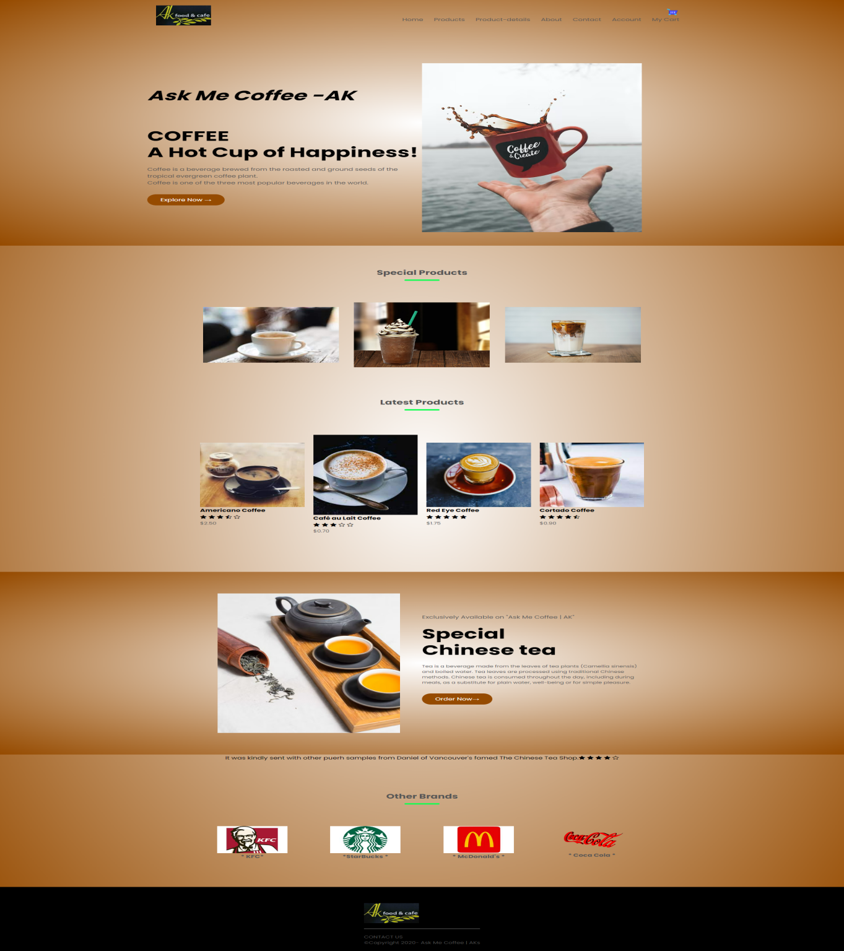

1. **PRODUCTS.HTML**

This products page contains all the products available in the shop. Along with product images contains its name, rating from the customers and along with its cost.

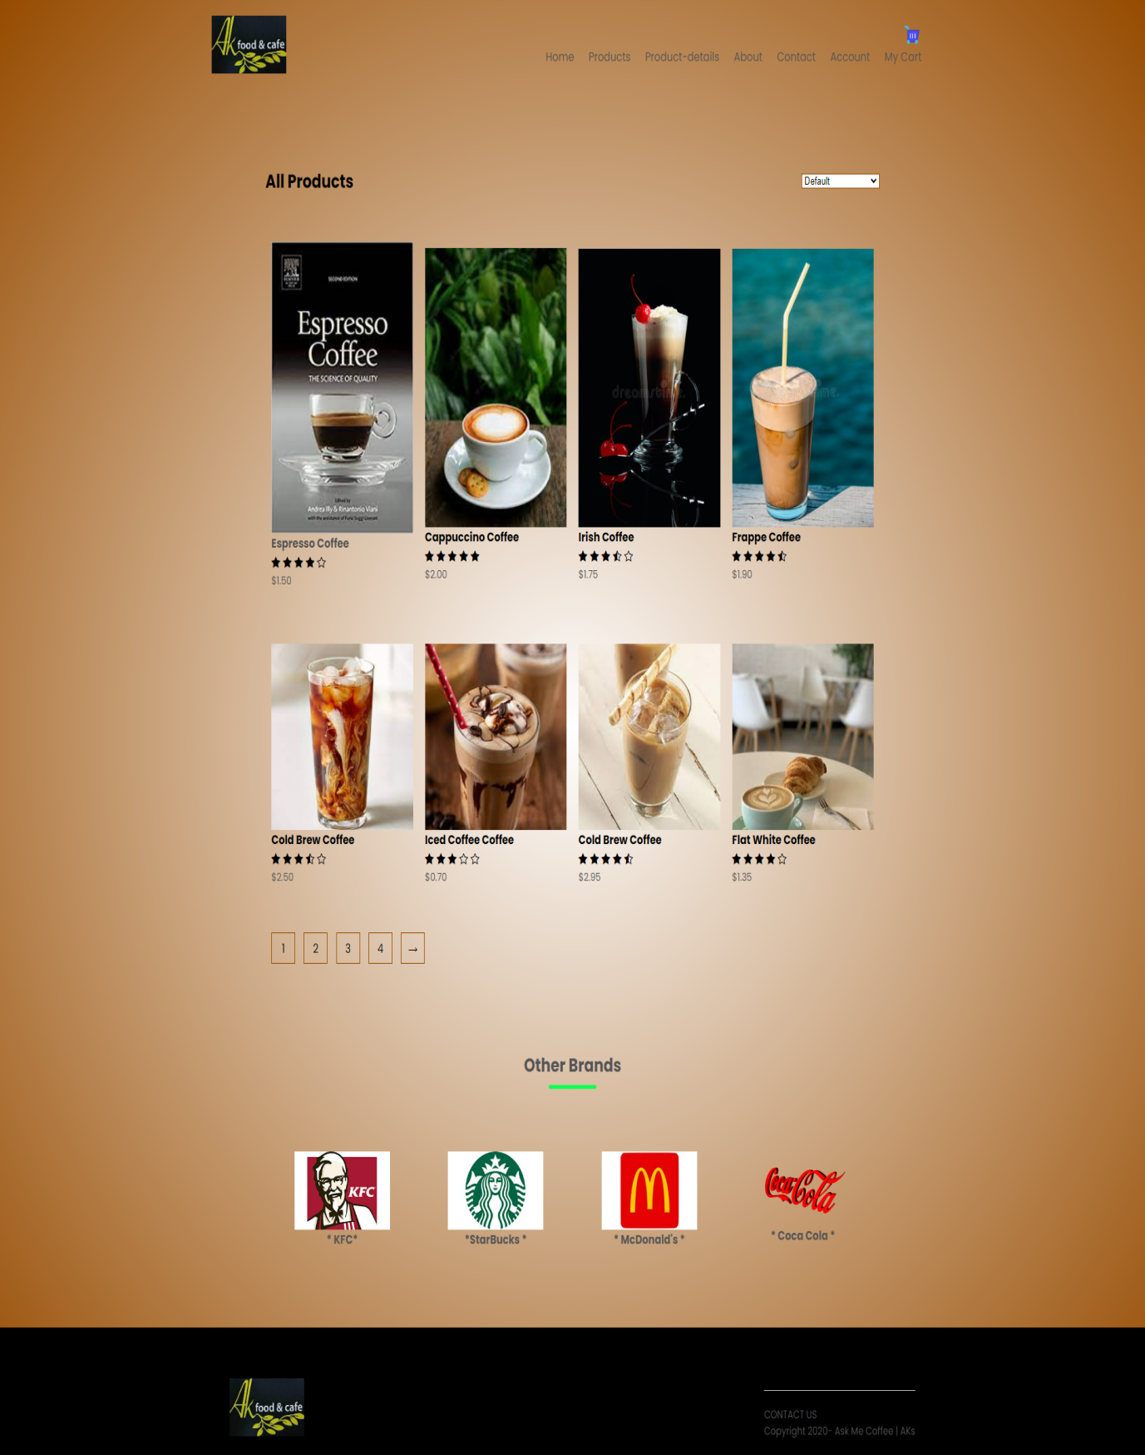

1. **PRODUCT-DETAILS.HTML**

This products-details page contains the complete information about the item and some related images to the item in tiny window.

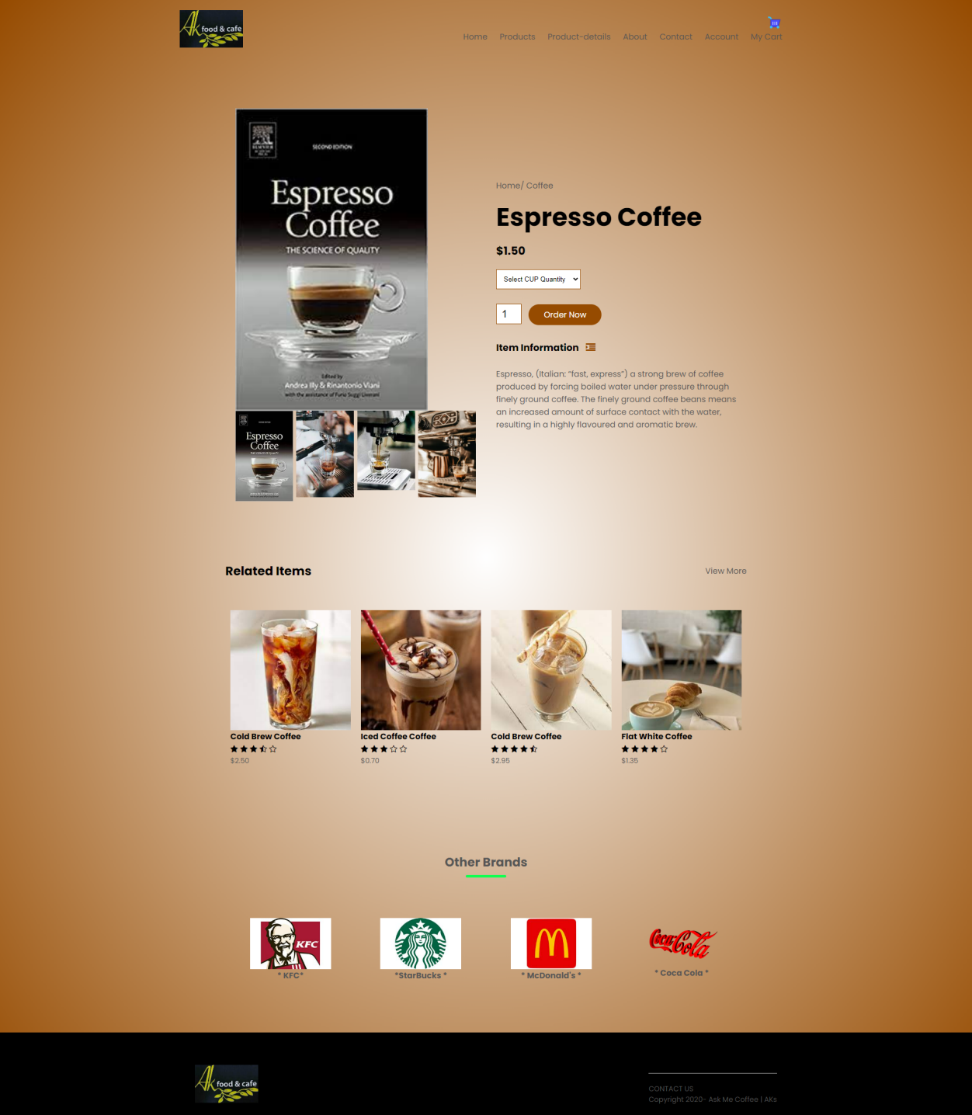

1. **ABOUT.HTML**

This about page provides the short information on this shop. And some important note on the coffee.

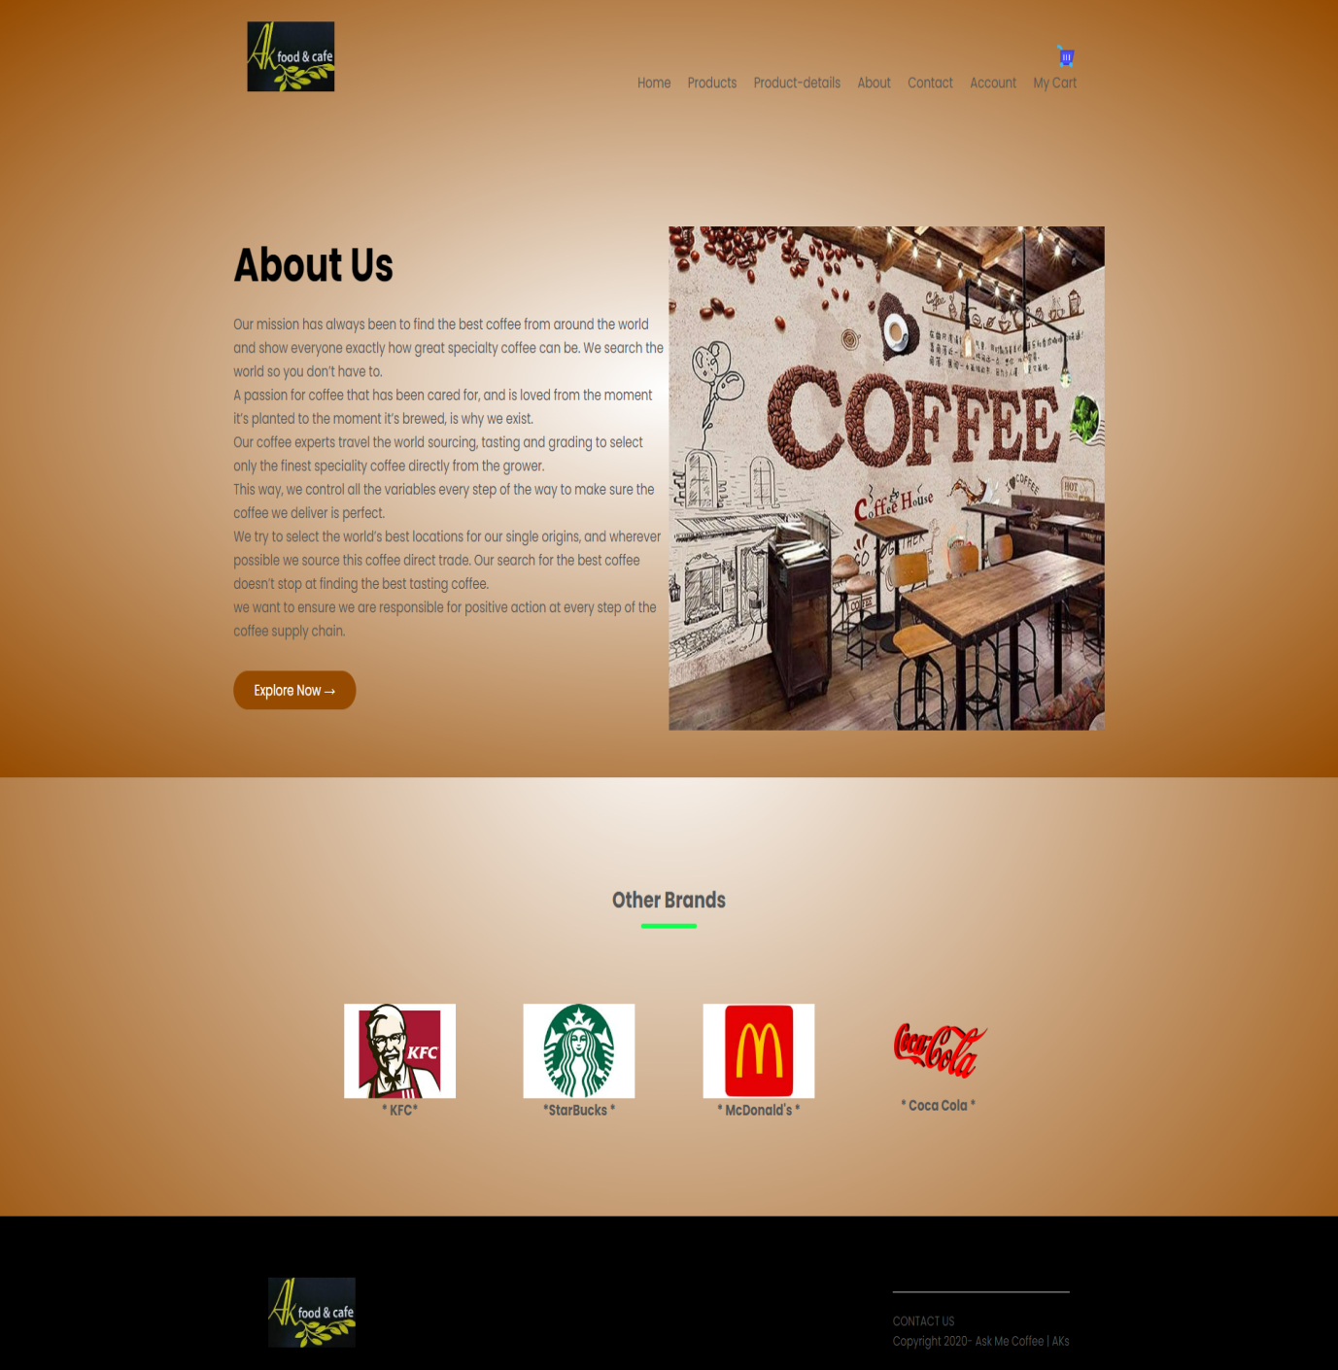

1. **CONTACT.HTML**

This contact page provides information about how to contact to this shop and other branches available at some places. There are three branches across the world under this coffee shop.

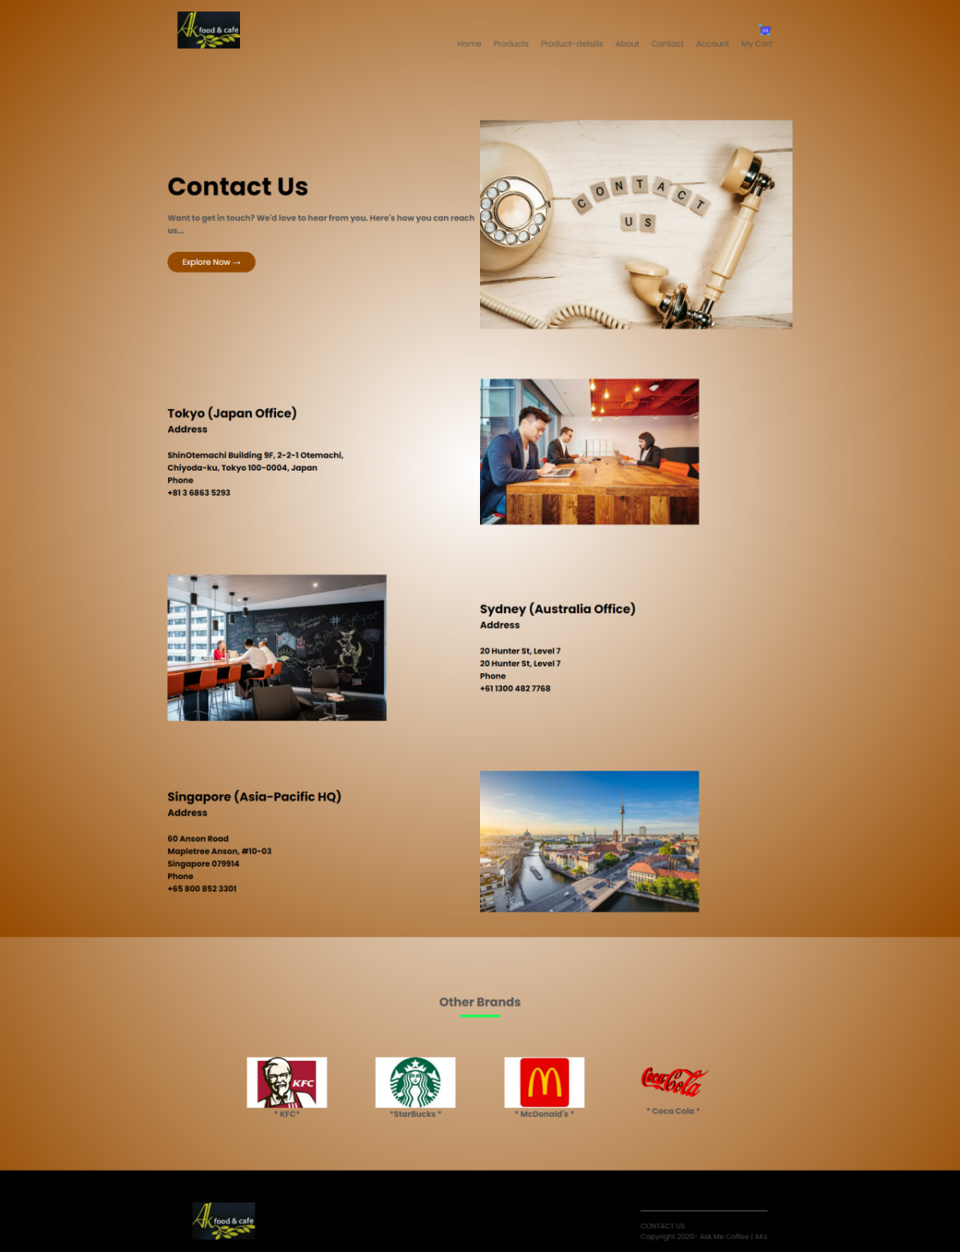

1. **ACCOUNT.HTML**

This account page is useful to us, to understand the customers and their ordered items.

For this we provided slide pages. one is for to login to the person who already has account in this shop.

And the other is for new customers to register.

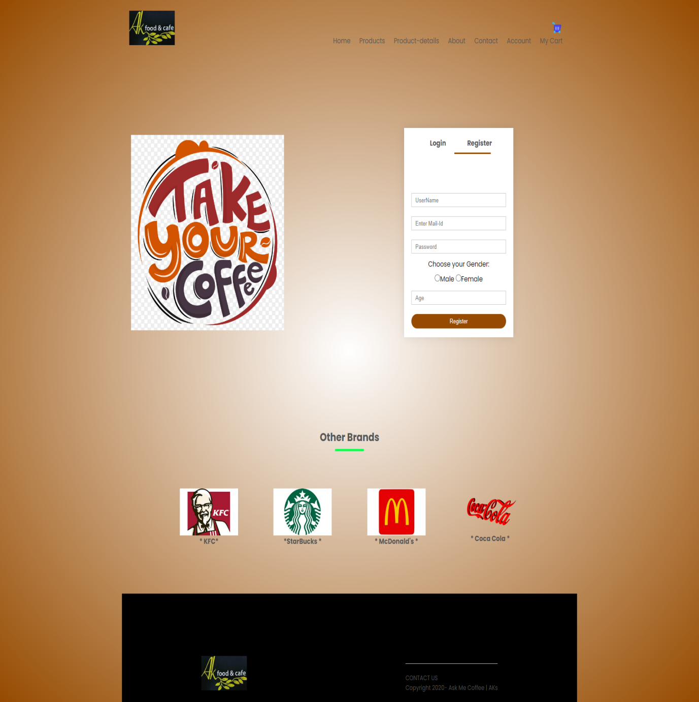

1. **CART.HTML**

**These** cart pages provide information about the total items and their cost in a table format to understand purpose.

The table contains item name , cost and quantity of the item ordered.

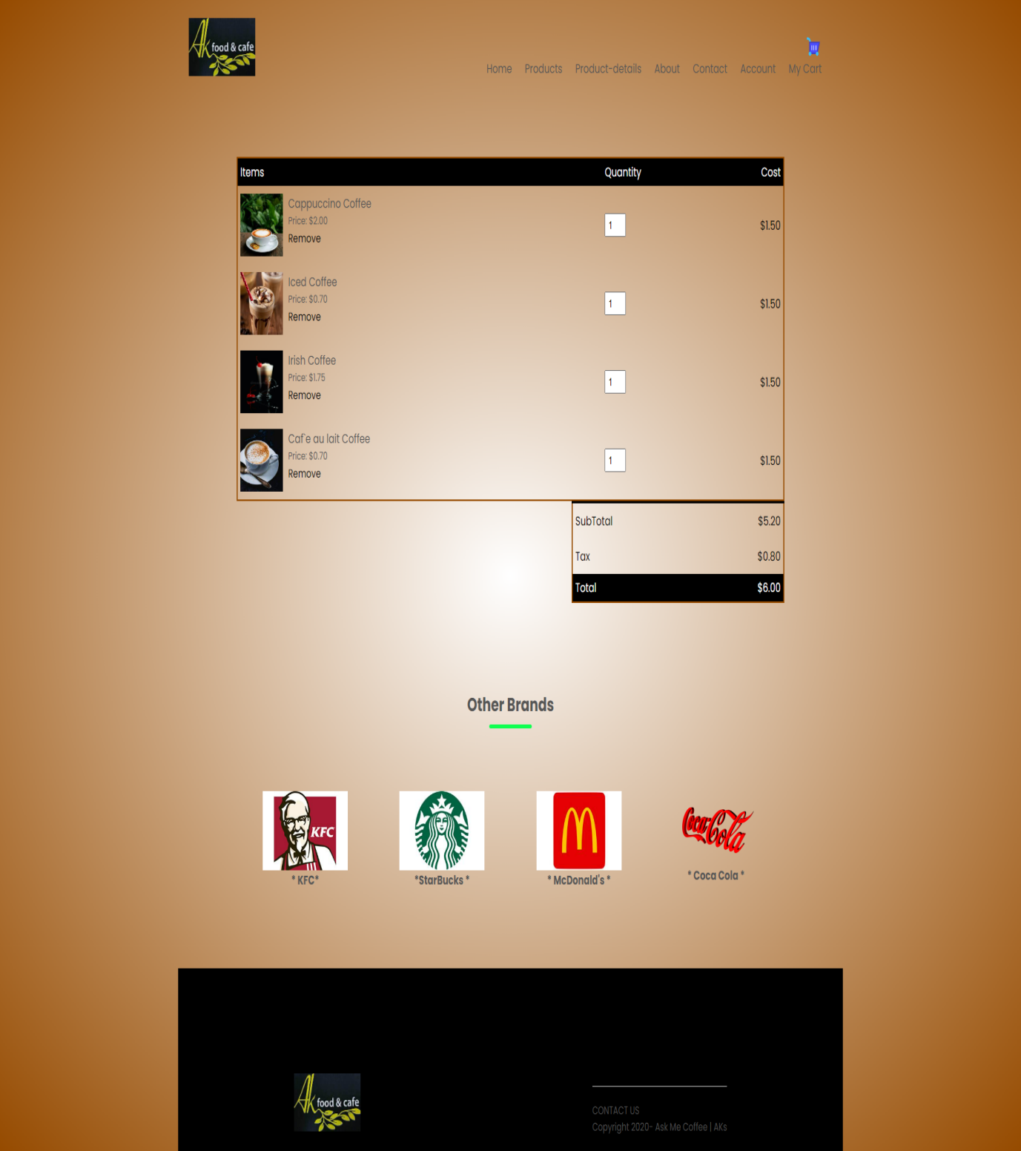

THANK YOU

THANK YOU